# Installing AFNetworking

## Step 1: Download

Download the source and uncompress to the harddrive.

<http://afnetworking.com/>

## Step 2: Add to you project

Drag the AFNetworking folder with source files to your project in XCode.

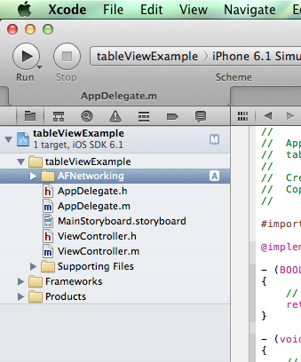 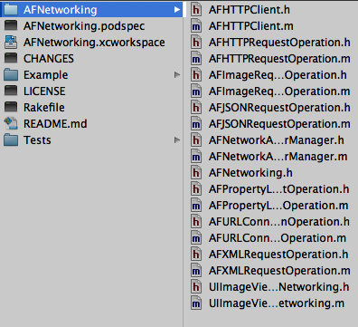

Make sure that you choose “Copy items into destination group’s folder”

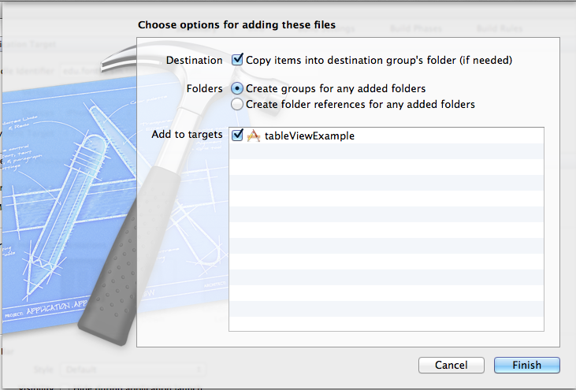

## Step 3: Add libraries

AFnetworking uses a security library that is not normally added to your project.

Select your project, select “targets’ -> ‘Build Phases’ and press the ‘+’ button.

Now choose ‘Security.framework’ and add it.

